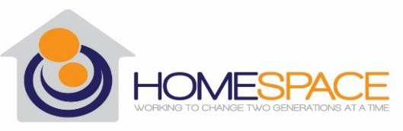

Performance Quality Improvement Plan 2022

Introduction

Since 1989 Homespace Corporation has been successfully helping young, at-risk individuals (age 14-21 years old) to forge a better life for themselves and their children. Homespace provides a safe, nurturing environment where these individuals can learn the skills to better themselves and their families, and break the cycle of public welfare dependency. In addition to comprehensive clinical services, individuals receive independent living skills training focusing on job-readiness, budgeting, household management, nutrition and parenting.
Homespace Corporation is a family. We are guided by integrity, treating everyone with dignity and respect. Our clients, guests, and staff are given the security of a safe and caring environment. We encourage empowerment driven by knowledge. Homespace succeeds when we work in collaboration with our internal and external partners who will help us achieve our mission.

Mission
Homespace Corporation supports at-risk young women to achieve independence two generations at a time.
Vision
Homespace Corporation strives to be the premier agency in WNY that provides services for at- risk young women and empowers them to be independent members of the community.
Values
Family ~ Self-Sufficiency ~ Responsibility ~ Security ~ Resiliency

Section 1: Homespace Corporation’s Philosophy of PQI

Homespace Corporation’s Performance and Quality Improvement (PQI) program promotes excellence and continuous improvement agency-wide in all of its programs. Homespace’s Board of Directors, Executive Director and supervisory staff place top priority on Performance Quality Improvement and strive for excellence. The leadership team endorses the collection and constructive use of data, which assists in evaluating every program, their services and all individuals and families served. In addition to regular evaluation and monitoring; planning, remediation, and improvement ensure our commitment to Performance Quality Improvement that creates a high-learning, high-performance, results-orientated environment.

Our PQI plan is broad and encompasses all employees, Board of Directors and identified stakeholders. More specifically, all levels of staff are involved in our PQI program through

annual training, staff meetings, data collection, annual surveys and quarterly feedback opportunities. All stakeholders participate in annual surveys and we specifically encourage this involvement and believe that the bottom up approach benefits our organization as a whole.

Section 2: Stakeholders

A major facet of our PQI program comes through continual interaction with our stakeholders. This provides us with an ongoing understanding of community and organizational needs, areas of improvement, understanding of community impact and collaborative ideas for the future.

The following is a list of our major stakeholders and how they engage in the PQI process:
- Clients
- Leadership
- Employees
- Board of Directors
- Community Members
- Funders

Stakeholder Group: CLIENTS

Description: The Clients served at Homespace Corporation are our primary stakeholder group. They consist of foster children, ages 14-21 who are recipients of residential care, independent living services and child placement.

What data do they provide?
Clients provide Homespace with data from annual and ongoing satisfaction surveys. Clients also provide outcome data through our program outcome measurement tools.

What information do they receive?
Clients have access to our quarterly and annual PQI reports posted on our website. They also receive feedback related to client satisfaction survey responses.

Stakeholder Group: LEADERSHIP

Description: The Leadership of Homespace includes the Executive Director, Administrative Director, Director of Program Operations and Director of Services.

What data do they provide?
Leadership provides overall program feedback throughout the year. They provide reports on outcome data that are analyzed by the PQI team. All Leadership staff are members of the PQI team.

What information do they receive?
Leadership receive quarterly and annual PQI reports and the Homespace Annual Report. They also receive the results of annual staff surveys, client surveys and external stakeholder surveys.

Stakeholder Group: EMPLOYEES

Description: Employees include Youth Support Specialists, Case Planners, Independent Living workers, mid-Management, Clinical and Administrative Staff.

What data do they provide?
Employees provide feedback in our annual employee satisfaction survey and suggestions at any time throughout the year. They also provide important data that is used to analyze program outcome measures. This data is collected in the form of reports, staff meetings and notes that pertain specifically to the clients. Finally, select employees are included in PQI meetings to provide insight into outcomes, tracking and trends.

What information do they receive?
Employees have access to our quarterly and annual PQI reports and the Homespace Annual Report. Employees also receive the results of the annual employee and client satisfaction surveys.

Stakeholder Group: BOARD OF DIRECTORS

Description: The Board of Directors at Homespace are a distinct group of community leaders which includes multiple disciplines that serves as a resource for the organization.

What data do they provide?
They provide feedback during regular Board and committee meetings.

What information do they receive?
The Board of Directors receive our quarterly and annual PQI reports. Additionally, they receive Homespace’s annual report and the audit.

Stakeholder Group: COMMUNITY MEMBERS

Description: Community members refer to partner organizations as well as the general public.

What data do they provide?
The Community provides feedback through our website which offers an opportunity to contact us and provide suggestions.

What information do they receive?
The Community has access to all information that is posted on the website, including the annual report, the PQI reports and general information about Homespace.

Stakeholder Group: FUNDERS

Description: Funders refer to the Erie County Department of Social Services (ECDSS) and New York State (NYS) who are the primary sources of support for Homespace. Additionally, Funders also include private foundations and individuals who give to Homespace either financially or materially.

What data do they provide?
Funders complete annual stakeholder surveys. ECDSS and NYS conduct regular audits and the results are provided to Homespace.

What information do they receive?
Funders have access to all information that is posted on the website, including the annual report, the PQI reports and general information about Homespace.

Section 3 – PQI Infrastructure

Homespace has developed an infrastructure to support our PQI process, and we continually look for ways to improve it.

The Compliance & Quality Assurance Officer (CQAO) acts as the PQI Coordinator and is responsible for the full implementation of the PQI plan and coordinates the PQI schedule, meetings, and deadlines. The CQAO aggregates all data provided through programs, surveys, strategic plans, annual plans and agency administration. The CQAO is responsible for quarterly and annual PQI reports.

The PQI Committee is comprised of the following positions:
  - Executive Director
  - Compliance & Quality Assurance Officer
  - Administrative Director
  - Program Directors
  - Human Resources Administrator
  - Other staff as determined by the committee

The PQI Committee meets on a quarterly basis. One Management Meeting per quarter is designated as the PQI meeting. The main activities conducted by the PQI committee include a review of quarterly collected data and analysis summaries to identify trends, strengths, and weaknesses. The committee reviews any survey data received from stakeholders and implements any needed work to address areas in need of improvement. They review progress towards completion of work plans and discuss any new trends or conclusions that may yield areas necessitating further study.

Below is a chart that shows how information is exchanged within the infrastructure of the PQI Program, including all stakeholders, leadership and governance.

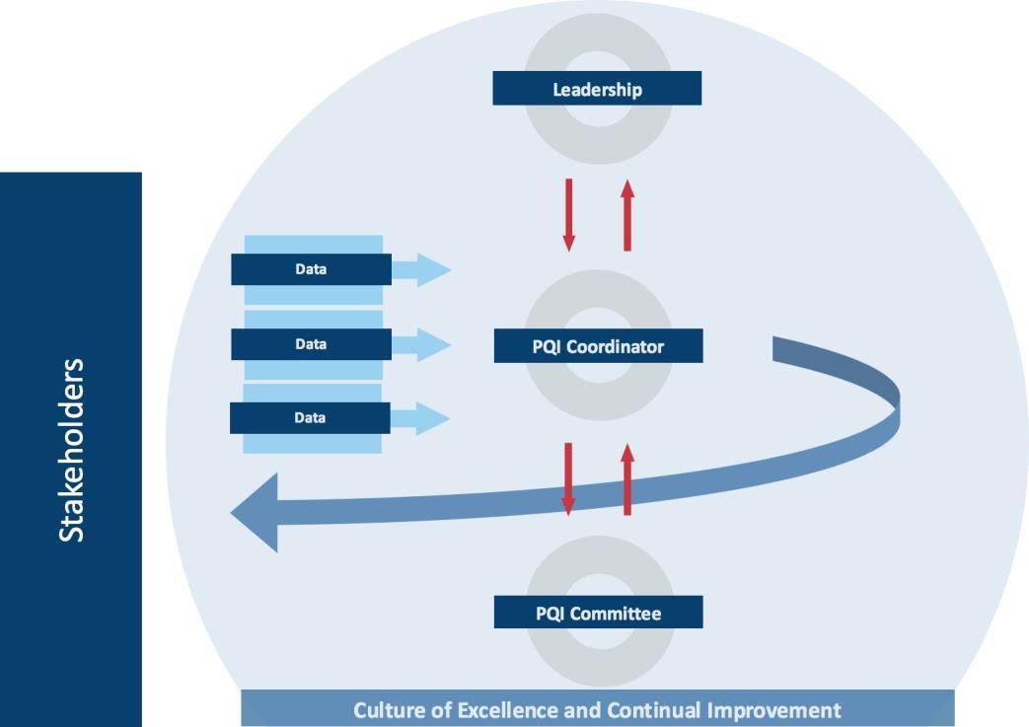

Data is first received by our stakeholders. It is filtered through the PQI Coordinator (CQAO) to assemble and present the data and findings, including strengths, weaknesses, opportunities and threats. The PQI Coordinator communicates this to the PQI Committee where much of the work is done to create improvements. The information is also communicated to the Board of Directors in order to implement a fully cohesive improvement plan.

Section 4 – Change Model

If it has been determined that change is needed in any capacity, Homespace utilizes the Plan, Do, Check and Act (PDCA) model.

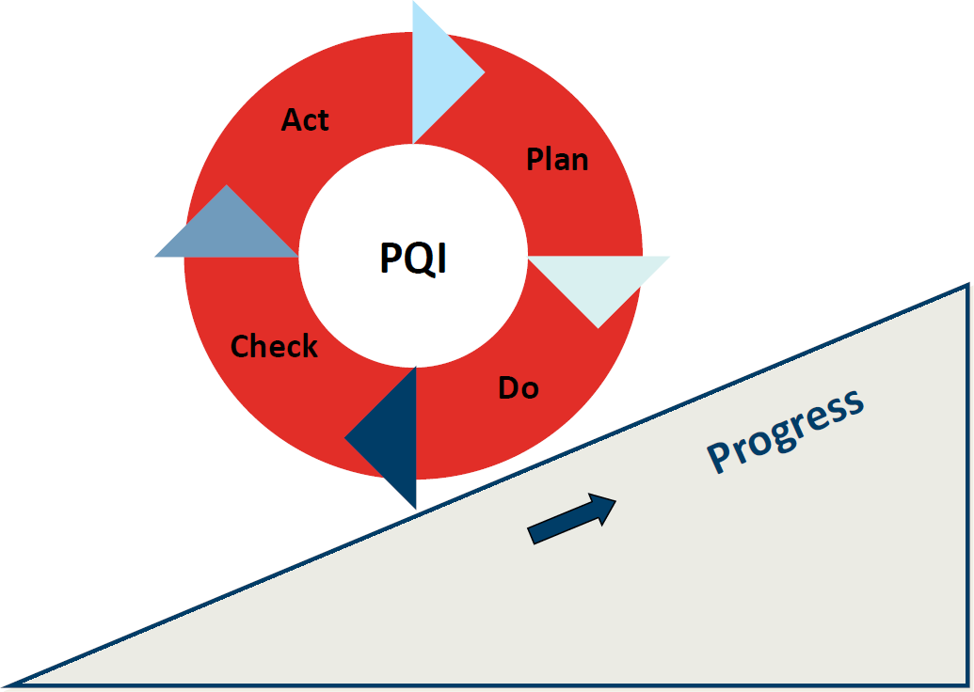

This model is flexible enough to adapt to a multitude of situations and contexts. It provides the PQI Committee and Coordinator enough structure and guidance to help develop and visualize Improvement Plans. Much of the data that Homespace receives is not indicative of change, but when it is, it is placed in an improvement plan and follows the PDCA model.
PLAN: This phase allows us to fully identify what the problem or area of improvement is, create a list of data to be collected, persons involved and a timeline. We identify goals, objectives and measurement outcomes to ensure that once the plan is enacted, we are able to measure its success and address any byproducts of the plan.
DO: The proposed plan is put into motion with check-ins and monitoring from the team as stated in the improvement plan.

CHECK: In this phase, the work is reviewed for positive and negative aspects of the change put into place. The plan will be compared with set measurement outcomes and evaluated to determine efficacy.
ACT: In this phase, we will make the determination if the change that was implemented was an improvement. If so, the change will be accepted and implemented. If it was not an improvement or the change produced negative byproducts, we will return to the previous mode of operation and implement the model of change again in order to develop a new plan for improvement.

Section 5 – Improvement Plans
An Improvement Plan will be implemented for the following reasons:
- When data collected through PQI indicates an area of concern (opportunity, weakness or threat)
- Increase administrative functions that need greater efficiency
- Correct under-performing programs
- For successful programs that Homespace would like to see grow or meet a new need

Section 6 – Areas of Measurement
For each program at Homespace, there are four types of indicators that are collected: outputs, outcomes, quality indicators and administrative review.
Typically, outputs look at the productivity of a program or department. It provides an indication of how much service is provided. Outcomes focus on whether or not the work that we conducted (outputs) actually created the desired change.
Along with the indicators for program performance, Homespace measures the quality of services. In addition to annual Client Satisfaction surveys, audits are conducted on all case files to ensure the following: 1) the quality of the work meets expectations, 2) necessary documentation is included, and 3) clients are receiving services that are delivered in an ethical and appropriate manner. Results of the client surveys and the file reviews are summarized and included in the PQI Quarterly Report.

Section 7 – Data Collection & Aggregation
Data is collected on a quarterly basis and is reviewed for accuracy, completeness, and timeliness. The resulting information is presented to the PQI committee for review and discussion to determine both trends that need to be addressed and any recommended improvement. Data are collected and reported in the following areas:

- Client and program outcomes – Logic Models for each service program
- Quality of programs and service delivery – Case record review and Client Satisfaction Survey
- Management/operational performance – Logic Model for Administration – Financial/HR

Section 8 – Strategic & Annual Planning Procedures
The Strategic Plan is reviewed and updated every four years, but progress towards goals is reviewed quarterly by the Board of Directors and other committees as appropriate. The Strategic Plan is updated regularly to account for current trends, needs and opportunities. Identifying the strengths and challenges that will help or hamper positive organizational growth is an important part of plan development.
The Board of Directors (BOD) engages in a regular strategic planning process in which it analyzes economic, demographic and policy trends and develops strategies to sharpen and deepen Homespace’s impact on the individuals being served. The BOD works with staff to evaluate program performance and continuously improve program quality.
Homespace’s management team creates and manages an annual work-plan, which lays out goals and priorities across the agency. This is reviewed and evaluated during the quarterly PQI meetings. A year-end summary of progress toward meeting these goals is included in the annual PQI report.

Section 9 – PQI Operational Procedures
The PQI team is responsible for promoting and participating in the PQI process, including the operational procedure outlined below:
- Identify long-term and short-term strategic goals
- Identify areas for improvement to help the organization meet those goals
- Develop projected solutions for quality improvement
- Set improvement targets
- Develop outcome measures and indicators
- Meet reporting requirements
- Participate in objective data interpretation
- Apply data to improve practices and outcomes

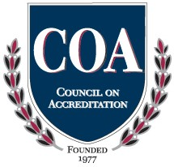
Program Indicators Worksheet
Admin.
Quality
Outcomes
Outputs

Performance and Quality Improvement
Program/Project/Operation:
Administration

Details
Average staff turnover and retention are measured on an annual basis.
The annual audit is completed within 6 months of the close of the fiscal year. Actual spending/revenue versus the budget is measured monthly
Documentation
Monthly reports as well as PQI Quarterly Reports are methods capture the administrative
functioning of the organization.
Items Measured
Average staff turnover Annual audit containing <6 nonmaterial misstatements Actual compared to budget
Details
This area is focused on direct service programs and not applicable to the administration of the organization.
Documentation
Not applicable
Items Measured
Not applicable
Details
Every year the Administrative Director, the HR Coordinator and the CQAO review the Employee Handbook and the Policy & Procedural manual. Internal processes are also reviewed for possible inefficiencies. Improvement plans are reviewed and created as needed.
Documentation
Meeting minutes and improvement plans provide documentation of this assessment occurring.
Items Measured
Financial Control Manual Employee Handbook Internal Processes
Details
While specific outcomes for Homespace are not present, as most of the goals are related to the achievement of specific benchmarks; the overall outcome is for Homespace to sustain in the community as a strong source of support.
Documentation
Outputs are summarized and reported in the PQI Quarterly Report. Leadership receives specific monthly reports on outputs produced.

Items Measured
Sustainability of the organization in the community.

Program Indicators Worksheet
Admin.
Quality
Outcomes
Outputs

Performance and Quality Improvement
Program/Project/Operation: Next Step

Details
The Next Step Independent Living worker tracks all outputs related to IL services every month. The Directors of Youth track all outputs related to CFTSS services every month. Although other outputs are collected, these outputs are consistently tracked and measured.
Documentation
A monthly report is provided to the PQI Coordinator. The outputs are included in the PQI Quarterly Report.
Items Measured
# of weekly IL Groups
# of Ind IL sessions
# of OLP sessions
# of CPST sessions
# of PSR sessions
# of weekly BH groups conducted
Details
Improved independent living skills as measured by the Casey Life Skills Assessment tool every 3 months
Decreased mental health symptoms as measured by PHQ-9 and the GAD-7 assessment tool every 3 months.
Documentation
The outcomes are aggregated quarterly and reported in the PQI Quarterly Report.

Items Measured
Change in Functional Status
Change in Clinical Status
Details
Performance on the quarterly case record review is measured. Client Satisfaction is gathered through annual client satisfaction surveys. Funders conduct periodic audits.
Documentation
File review results are documented in the PQI Quarterly Report. Client Satisfaction
numbers are reported in the PQI Quarterly Report.

Items Measured
Case Record Review
Client Satisfaction
Audits by funders
Details
Every year, the Director of Program Operations and Directors of Youth conduct a thorough review of the processes and procedures at Next Step. If needed, Improvement Plans will be developed.
Documentation
Meeting minutes and improvement plans provide documentation of this assessment occurring.
Items Measured
Internal Reviews and Improvement Plans

Program Indicators Worksheet
Admin.
Quality
Outcomes
Outputs

Performance and Quality Improvement
Program/Project/Operation: Second Chance Home

Details
The Second Chance Home Independent Living worker tracks all outputs related to IL services every month. The Directors of Youth track all outputs related to CFTSS services every month. Although other outputs are collected, these outputs are consistently tracked and measured.
Documentation
A monthly report is provided to the PQI Coordinator. The outputs are included in the PQI Quarterly Report.
Items Measured
# of weekly IL Groups
# of Ind IL sessions
# of OLP sessions
# of CPST sessions
# of PSR sessions
# of weekly BH groups conducted
Details
Improved independent living skills as measured by the Casey Life Skills Assessment tool every 3 months
Decreased mental health symptoms as measured by PHQ-9 and the GAD-7 assessment tool every 3 months
Documentation
The outcomes are aggregated quarterly and reported in the PQI Quarterly Report.

Items Measured
Change in Functional Status
Change in Clinical Status
Details
Performance on the quarterly case record review is measured. Client Satisfaction is gathered through annual client satisfaction surveys. Funders conduct periodic audits.
Documentation
File review results are documented in the PQI Quarterly Report. Client Satisfaction
numbers are reported in the PQI Quarterly Report.

Items Measured
Case Record Review
Client Satisfaction
Audits by funders
Details
Every year, the Director of Program Operations and Directors of Youth conduct a thorough review of the processes and procedures at Second Chance Home. If needed, Improvement Plans will be developed.
Documentation
Meeting minutes and improvement plans provide documentation of this assessment occurring.
Items Measured
Internal Reviews and Improvement Plans

Program Indicators Worksheet
Admin.
Quality
Outcomes
Outputs

Performance and Quality Improvement
Program/Project/Operation: SILP

Details
The SILP Independent Living worker tracks all outputs related to IL services every month. The Directors of Youth track all outputs related to CFTSS services every month. Although other outputs are collected, these outputs are consistently tracked and measured.
Documentation
A monthly report is provided to the PQI Coordinator. The outputs are included in the PQI Quarterly Report.
Items Measured
# of weekly IL Groups
# of Ind IL sessions
# of OLP sessions
# of CPST sessions
# of PSR sessions
# of weekly BH groups conducted
Details
Improved independent living skills as measured by the Casey Life Skills Assessment tool every 6 months
Decreased mental health symptoms as measured by PHQ-9 and the GAD-7 assessment tool every 3 months
Documentation
The outcomes are aggregated quarterly and reported in the PQI Quarterly Report.

Items Measured
Change in Functional Status
Change in Clinical Status
Details
Performance on the quarterly case record review is measured. Client Satisfaction is gathered through annual client satisfaction surveys. Funders conduct periodic audits.
Documentation
File review results are documented in the PQI Quarterly Report. Client Satisfaction
numbers are reported in the PQI Quarterly Report.

Items Measured
Case Record Review
Client Satisfaction
Audits by funders
Details
Every year, the Director of Program Operations and Directors of Youth will conduct a thorough review of the processes and procedures in the SILP Program. If needed, Improvement Plans will be developed.
Documentation
Meeting minutes and improvement plans provide documentation of this assessment
occurring.
Items Measured
Internal Reviews and Improvement Plans

