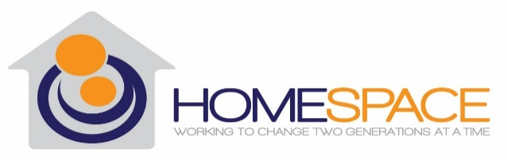

Performance Quality Improvement
1st Quarter Report 2022

Introduction
In November of 2021 Homespace Corporation’s Board of Directors (BOD) approved Homespace’s agency-wide 2022 Performance and Quality Improvement Plan, designed to improve services and help Homespace provide the highest quality programming.
Homespace values a culture of continual improvement as a process that facilitates growth and positive change. The Performance and Quality Improvement (PQI) Program is still in the early phases of development, but adequately supports the collection of data from many of its stakeholders. The BOD and Senior Leadership of Homespace are committed to allocating resources, both monetary and human, to ensure innovative programming based on data.
Homespace has several programs and departments, each with goals and outcomes that are measured as part of PQI. Each program and department was required to develop separate logic models, identifying areas of measurement. In this first report we will share our goals and how we did in the first quarter of 2022. As we continue to strive for excellence in our programming and to improve our PQI program, we invite any and all feedback. We value the opportunity to improve and encourage you to contact Samantha White at 716-220-7538 with any suggestions or questions.
Overview
As this is Homespace’s first quarterly report, we want to outline the specific measures for each program and department. As we progress in our understanding and evaluating measures, we hope to include information that is valuable to all our stakeholders, including client satisfaction surveys, employee satisfaction surveys, financial overviews, progress on the organization’s annual plan and other relevant information.
Homespace has three main programs: Second Chance Home (SCH), Next Step Program (NS) and the Supervised Independent Living Program (SILP). Our Administrative team supports all of our programs.

Program Outputs
Homespace measures several outputs and two outcomes for each program. The Outputs tracked this quarter for all programs were:
- # of individual Independent Living sessions conducted with clients
- # of group Independent Living sessions conducted with clients
- # of individual OLP sessions conducted with clients
- # of individual CPST sessions conducted with clients
- # of group Behavioral Health sessions conducted
All of our Independent Living and Mental Health Outputs were on target for frequency of services. During the quarter we measured other outputs that we determined did not necessarily provide valuable information, so we will not report on them this quarter and will slightly revise the Logic Models and the Program Indicators Worksheets to reflect this.
Additionally, we compared total number of clients served this quarter versus the same time last year.

2021 Q1 Census Data | 2022 Q1 Census Data
SILP – 13 clients, 4 children | SILP – 12 clients, 4 children
Community SILP – 7 clients, 5 children | Community SILP – 9 clients, 6 children
Next Step – 5 clients | Next Step – 6 clients
Second Chance Home – 4 clients, 4 children | Second Chance Home – 3 clients, 4 children

While Next Step’s census has been close to or at capacity, Second Chance Home’s census has been far below capacity since January 2021. Additionally, while the SILP has more clients than the other programs with more stable census numbers, 10 clients will be aging out of the foster care system by the summer and we have received zero referrals in the last 5 months. An Improvement Plan will be implemented to address low census.

Program Outcomes
Outcomes focus on sustainable change that demonstrate our interventions work, and that clients and the Homespace team are making progress toward their goals. These outcomes are evidence based and are dependent upon the specific tool that is being used by the program. Outcomes information is collected quarterly. Please note that not all goals are measured quarterly and will be reported on in future reports.
The following are the outcomes and the first quarter progress by Department:
Second Chance Home (SCH) and Next Step Program
Clients will improve their Independent Living (IL) skills by an average of 10% as measured by the Casey Life Skills assessment tool every 3 months.
Results – on average clients showed a 2.9% decrease in IL skills
- There were 9 total clients during this quarter. 4 clients total had 2 assessments. 2 clients out of 9 were discharged before their 2nd assessment. 3 clients out of 9 were new intakes, thus they only had their initial assessment.

60% of clients will show a decrease in mental health symptoms as measured by the PHQ-9 and GAD-7 every 3 months.
Results – 50% of clients showed an improvement of anxiety symptoms as measured by the GAD-7. 50% of clients showed an improvement of depression symptoms as measured by the PHQ-9. 1 client showed an improvement of both anxiety and depression symptoms.
- There were 9 total clients during this quarter. 4 clients total had 2 assessments. 2 clients out of 9 were discharged before their 2nd assessment. 3 clients out of 9 were new intakes, thus they only had their initial assessment.
There were not enough clients to make either of these measurements statistically meaningful. The sample size was too small due to low census particularly at Second Chance Home. This illustrates the need for an Improvement Plan to address census issues. We will continue with these outcomes with the goal of increasing the census thus increasing the sample size.
Homespace utilizes the Plan Do Check Act methodology for change and will complete this cycle for this goal.
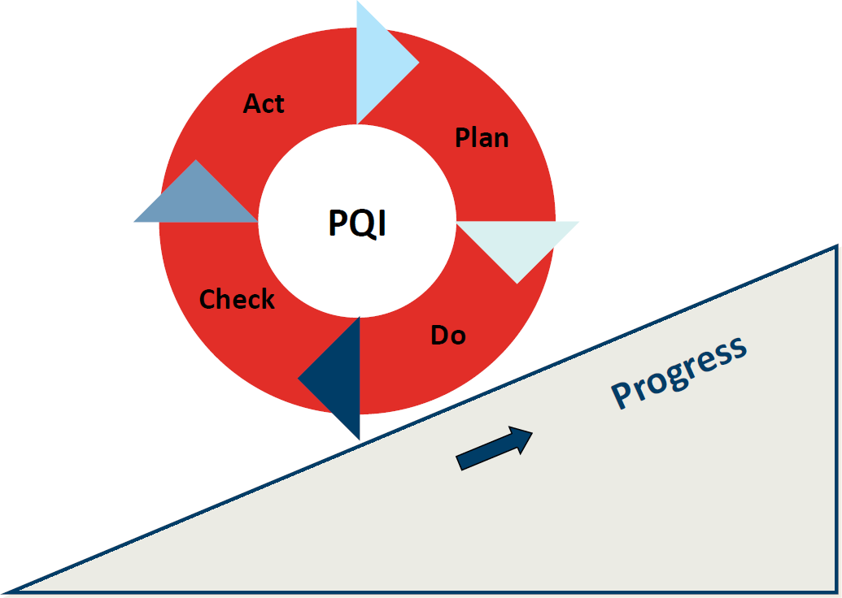

Supervised Independent Living Program (SILP)
Clients will improve their IL skills by an average of 10% as measured by the Casey Life Skills assessment tool every 6 months.
Results – this outcome will be measured next quarter
60% Clients will show a decrease in mental health symptoms as measured by the PHQ-9 and the GAD-7 assessment tools every 3 months.
Results – 20% of clients showed an improvement of anxiety symptoms as measured by the GAD-7. 20% of clients showed an improvement of depression symptoms as measured by the PHQ-9.
- There were 17 total SILP clients during this quarter. 5 of 17 clients total had 2 assessments. 2 clients out of 17 were discharged during the quarter. 2 clients had only 1 assessment. 8 out of 17 clients had 0 assessments.
8 out of 17 clients had no assessments completed. These clients are currently not required to engage in Behavioral Health Services and have refused such. All new intakes are now required to participate in Behavioral Health Services so the number of clients with completed assessments is expected to increase next quarter.
Administration
Our Administrative team is also working to improve its internal processes and services to our internal (programs) and external partners. The Administrative team has set up goals to help us measure employee satisfaction and retention, and fiscal stewardship. This quarter we specifically tracked our retention rate and our actual revenue versus the budget. The following was noted:
Homespace’s attrition rate tracked over the last two quarters averaged 10% which met our goal.
Review of Homesapace’s actual spending/revenue versus the budget revealed deficits each month throughout the quarter primarily due to low census numbers. While correspondingly our expenses are lower, there still remains a significant quarterly deficit. The following actions have been initiated:
- There are grant applications in process that will likely be approved this year that are not currently reflected in the budget.
- The Administrative Director is conducting a cash flow analysis.
- All departments have been asked to identify ways to cut expenses and to identify other potential sources of revenue.
- YSS staff are being trained to provide PSR and CPST services to increase billable services thus increasing revenue.
- As mentioned above, an Improvement Plan will be implemented to address low census.

Case Record Review Summary
According to Homespace’s Utilization Review (UR) Policy, case files are reviewed according to a set schedule and the results of the review are compiled into a quarterly report with an emphasis on certain quality indicators.

SILP Case Record Review Summary:

- Some noted deficiencies were due to a delay in printing and filing completed paperwork. We will revise the UR Procedure such that Case Planners will be notified prior to their files being UR’d so all filing will be up to date.
- Medical Information was missing from many files. Due to the nature of the program, clients are encouraged to schedule and attend their own appointments. They generally speak with their Case Planners about this information but rarely provide appointment summaries or copies of medical assessments. The Medical Case Manager will be taking on the responsibility of gathering all medical information over the next few months, however, clients can still decline to share information.
- See review summary for additional information.
Residential Case Record Review:
- Due to staffing issues, there were challenges in completing the Residential URs according to the established schedule. Thus, the Case Record Review Summary was not completed in time for the quarterly PQI Committee meeting. A temporary employee has been retained to complete all outstanding UR’s and provide a summary report within the next three weeks. Additionally, this employee will complete all agency URs through August while a new UR procedure is developed.
Other Challenges
We identified that we lacked of good system for our Behavioral Health workers to provide output numbers to the person responsible for recording the data. Going forward our process will be as follows:
- The Administrative Assistant will track all Outputs
- IL & BH workers will use a standardized output tracking template and send information to the Administrative Assistant at the end of each month
- All assessment information will be sent to Administrative Assistant quarterly
Next Steps
Going forward in addition to reporting on the outputs and outcomes contained in this report, we intend to include results of employee and client satisfaction surveys and progress with our Annual and Strategic Plans.
Also in the future we hope to present our quarterly reports in more of a newsletter format with more sophisticated graphics.
We value our Stakeholders. If you would like to share your thoughts on our first PQI report, please contact our PQI Coordinator, Samantha White at 716-220-7538 or Samantha.white@homespacecorp.org with any comments, suggestions or questions.

