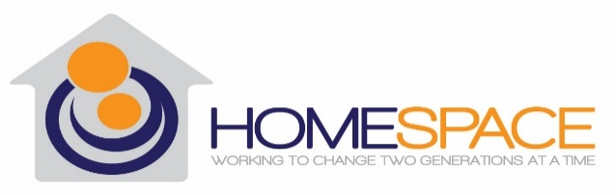

Performance Quality Improvement
4th Quarter Report 2023

Introduction/Overview
In November of 2021 Homespace Corporation’s Board of Directors (BOD) approved Homespace’s agency-wide 2022 Performance and Quality Improvement (PQI) Plan, designed to improve services and help Homespace provide the highest quality programming. This 4th Quarterly Report for 2023 is for all stakeholders, including clients, staff, Board of Directors, community members, funders and any individual who is interested in the great work that we do. PQI is an integral part of our organization, and we are always open and willing for new opportunities to change and grow.
Through this report we want to provide information on both accomplishments and opportunities for improvement. At times we fall short of our goals and targets. As an organization, we seek to learn from our experiences. Being able to take ownership of our shortcomings and work to improve them is an underlying philosophy of our organization.
In this report we will share our goals and how we did in the 4th quarter of 2023, outlining the specific measures for each program and department. As we continue to strive for excellence in our programming and to improve our PQI program, we invite any and all feedback. We value the opportunity to improve and encourage you to contact Samantha White at 716-220-7538 with any suggestions or questions.
Program Outputs
Homespace has three main service programs: Second Chance Home (SCH), Next Step Program (NS) and the Supervised Independent Living Program (SILP). We measure several outputs and two outcomes for each of these programs. The Outputs tracked throughout 2023 were related to the Children and Family Treatment and Support Services (CFTSS) that we provide to clients in all of our programs.
CFTSS Outputs Tracked Quarterly for all programs as follows:
Output | Budgeted Per Quarter | Actual (Q3) | Actual (Q4) | Budgeted YTD  (4 Quarters) | Actual YTD  (4 Quarters)
OLP Sessions | 141 | 118 | 66 | 564 | 467
OLP Groups | 25 | 15 | 7 | 100 | 64
CPST Sessions | 105 | 160 | 112 | 420 | 596
CPST Groups | 25 | 3 | 24 | 100 | 82
PSR Sessions | 105 | 51 | 43 | 420 | 157
PSR Groups | 12 | 0 | 0 | 48 | 2

While certain areas were below stated goals, we exceeded the total CFTSS budgeted goals for the year.
Census 2023 – Days of Care
The charts below represent both actual and average days of care compared to budgeted. In 2024 we will monitor Days of Care quarterly through the PQI Program.
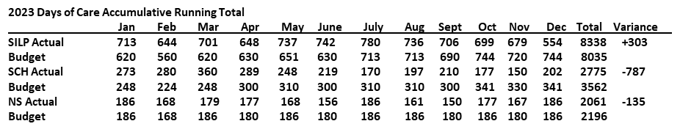
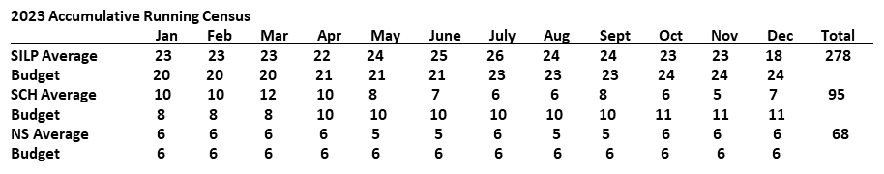
Outcomes
Service Programs
In 2023, we tracked Outcomes related to “Permanency of Life Situation” and “Health, Welfare and Safety”. Specifically, we measured clients’ stability and success in our programs and clients’ feelings of safety and security. Both Outcomes were measured every 6 months.
Permanency of Life Situation
Goal - 75% of clients will be stable in their program, make a successful planned transition or a successful planned discharge measured every 6 months.

Results – 80% of SILP clients were stable in the program or made a successful planned transition. 68% of residential clients were stable in the program or made a successful planned transition. These numbers indicate our inventions are working.

Program | Total # of Clients | # Stable in Program | # Planned Transition or Discharge | Percentage
SILP | 25 | 10 | 10 | 80%
Residential | 22 | 10 | 5 | 68%

Despite Homespace’s interventions, some clients do not remain in their program for the following reasons:
- AWOL – client did not return
- Homespace requested removal due to noncompliance, fighting or drug use
- Client signed out of care with no plan
- Client required a higher level of care (RTF, RTC, Detention)
- Client aged out of foster care without a suitable transition plan due to program non-compliance

Health, Welfare and Safety
Goal - 75% of clients will report feeling safe and secure in their program as measured by client satisfaction surveys conduct every 6 months.
Results – 14 out of 26 total clients completed the survey (54%). Of those, 64% reported always feeling “safe and secure” in their Homespace program and 36% reported that they sometimes feel “safe and secure” (see below for additional survey results).
Administration – Human Resources and Finance
Our Administrative team is also working to improve its internal processes and services to our internal (programs) and external partners. The Administrative team has set up goals to help us measure employee retention rate and employee satisfaction/engagement; and fiscal stewardship focusing on our revenue and expenses.

Human Resources

Homespace’s attrition rate for the 4th quarter was 4.74% with one voluntary leaver and two involuntarily leavers.
Our year-end total attrition rate was 21.2% well below the national average of 60%.
The 4th Quarter Employee Engagement Survey was conducted with 38% of the total number of employees participating. The overwhelming majority reported being satisfied with workplace flexibility, that they feel respected at work and are satisfied with the overall work environment.
Finance
Review of year-end Revenue versus Expenses revealed a Total Net Income of $324.995.90.

Client Satisfaction
Client satisfaction surveys were distributed in November & December of 2023 to all clients residing in a Homespace program. During the survey period a combined 26 clients were being served at Next Step, Second Chance Home, SILP, and Community SILP. Out of these 26 clients, 14 of them completed the survey (54%).

The majority of clients reported overall satisfaction with Homespace; reported feeling safe and secure; that their medical, educational and mental health needs were being met; and that they were being helped to meet their personal goals.

Case Record Review Summary
According to Homespace’s Utilization Review (UR) Policy, case files are reviewed according to a set schedule and the results of the review are compiled into a quarterly report with an emphasis on certain quality indicators.
All scheduled reviews were completed this quarter. Measures related to annual medical assessments and immunizations records continue to show a lack of improvement, however, most client files show record requests for medical information, which was an action item in our current Improvement Plan.
Follow-up reviews were also conducted on Case Record Reviews from the 3rd quarter that required remediation. The follow-up showed improvement on missing clinical items. Documentation was still missing for medical information, however, there was evidence that those records had been requested.
Improvement Plan Update
During the 1st quarter we identified the need for an Improvement Plan to address issues revealed through our Case Record Review process. Consecutive reviews did not meet both regulatory and our own internal standards for medical documentation, specifically documentation related to annual medical assessment, immunization records, and vision and medical assessments.
All action items in the Improvement Plan were completed and there was sufficient improvement noted in the Case Record Reviews. Thus, the Improvement Plan will be retired.

Strategic Plan
The Strategic Plan was reviewed at the December 12, 2023, Management Meeting. All Annual Plan action items have been completed. Work on a new Strategic Plan will begin in early 2024.

We value our Stakeholders. If you would like to share your thoughts on any of our PQI reports, please contact our PQI Coordinator, Samantha White at 716-220-7538 or Samantha.white@homespacecorp.org with any comments, suggestions or questions.

